**Use Address(Text) in smartforms**

1. Go to tcode smartforms
2. Select the Radio button Form. Give name starting with Z/Y. Click on create

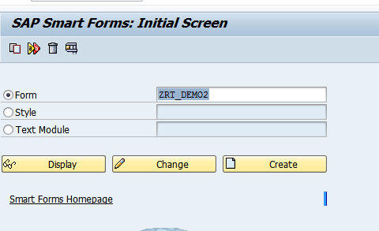

1. Expand Pages and windows folder.

Right click on First Page-Create-Window

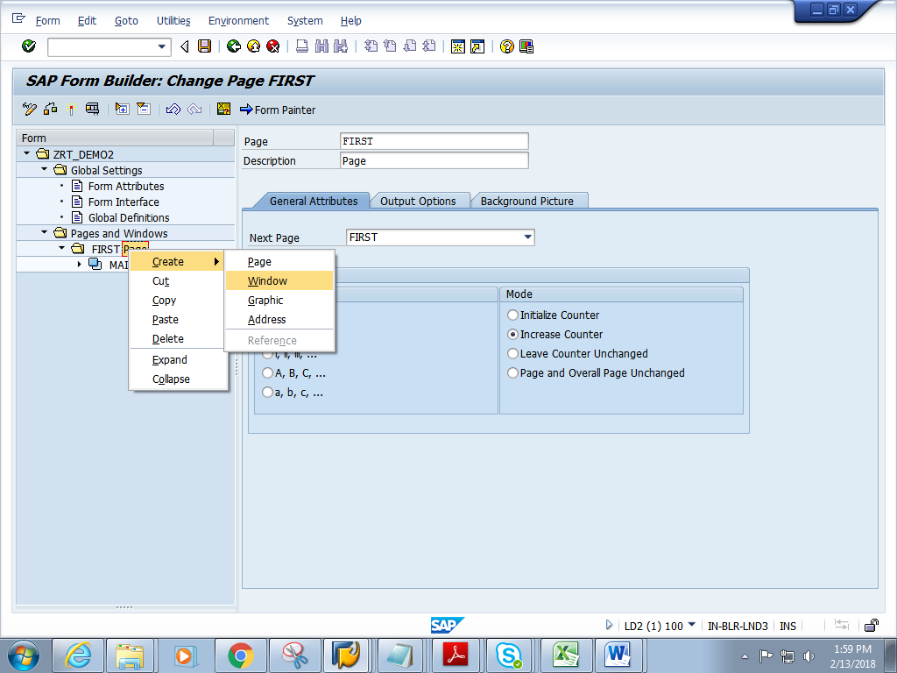

1. Give short description and name.

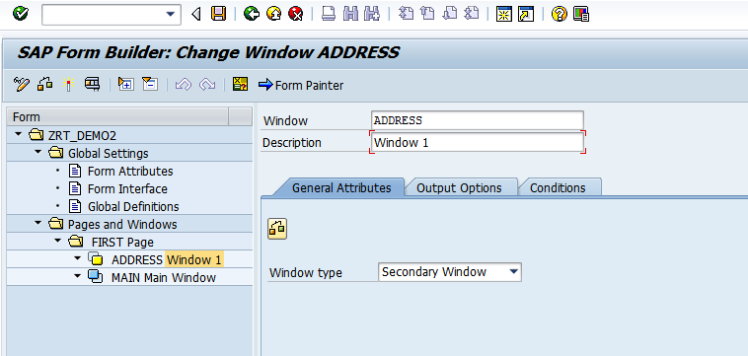

5) Right click on Address window. Create-text

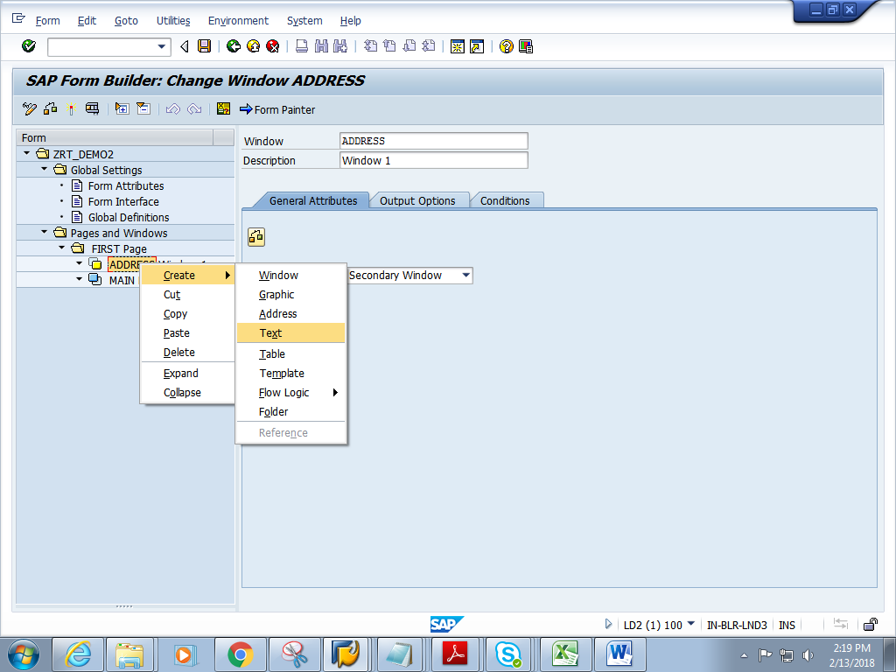

6) Double click on TEXT1. Below screen appears.Give short description and name.

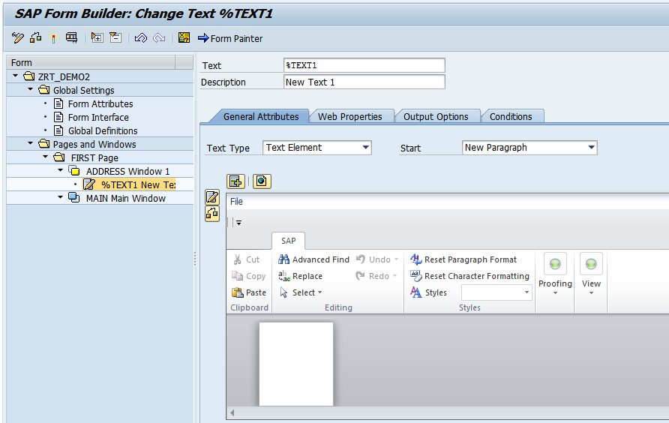

7) Click on the editor

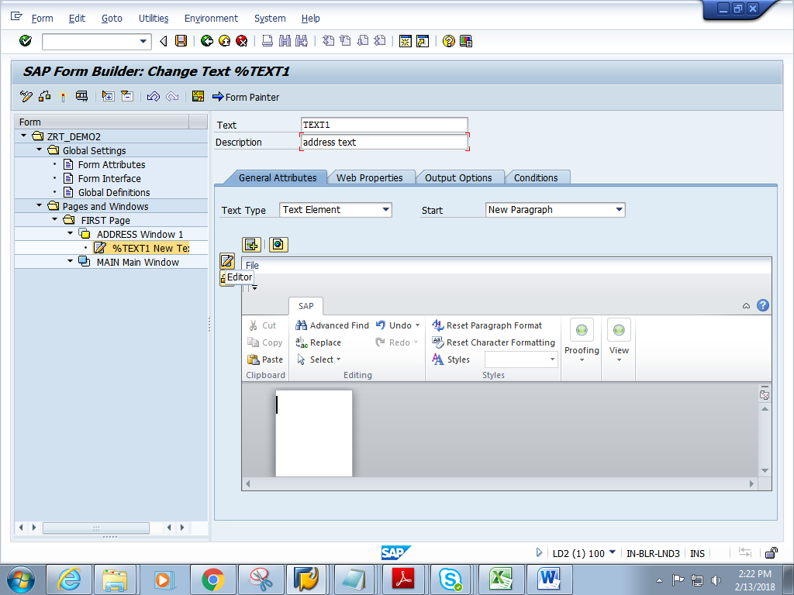

8) Goto-Change Editor

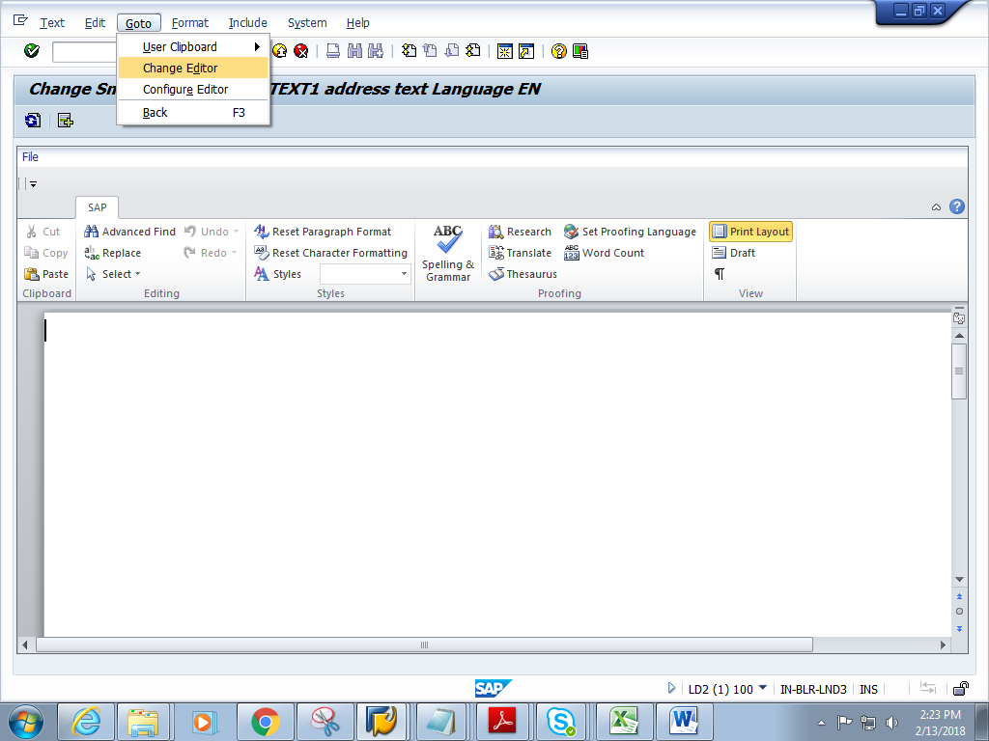

9) Enter any address. Click on Back button

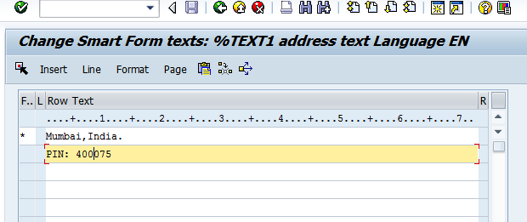

10 ) Click on Form Painter. Adjust the address window by dragging it and place it in suitable position.

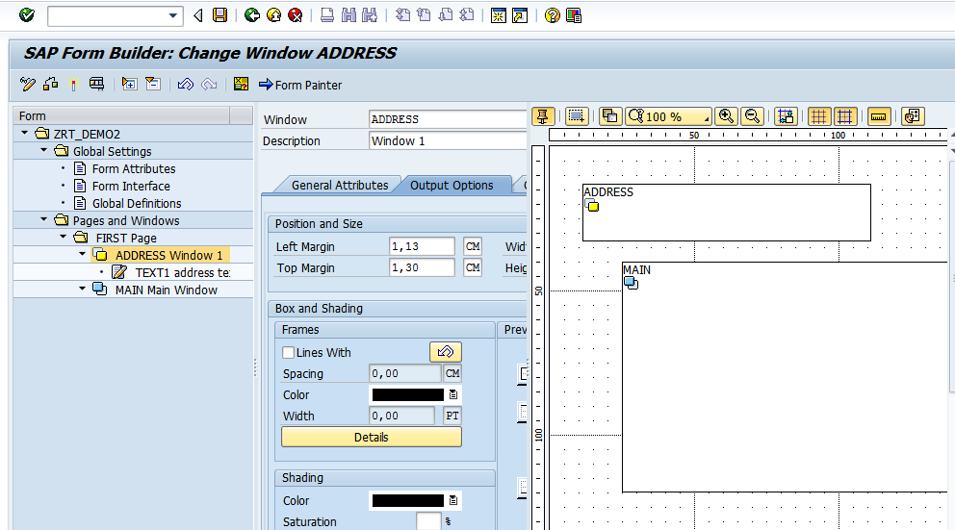

11) Save and activate the form.

12) Execute the form .Execute the function module

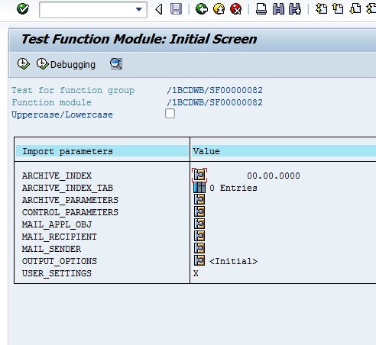

13) Click on Print preview

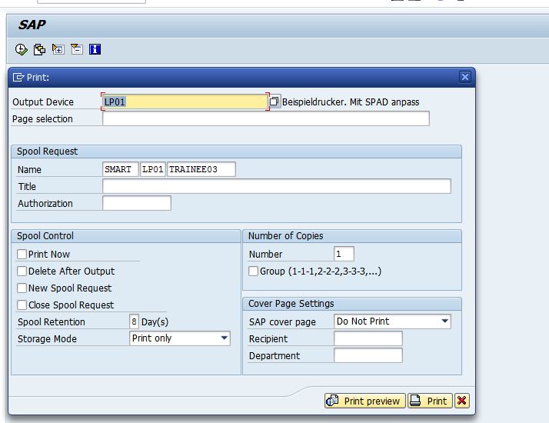

14) Expected output is as follows.

